Topics

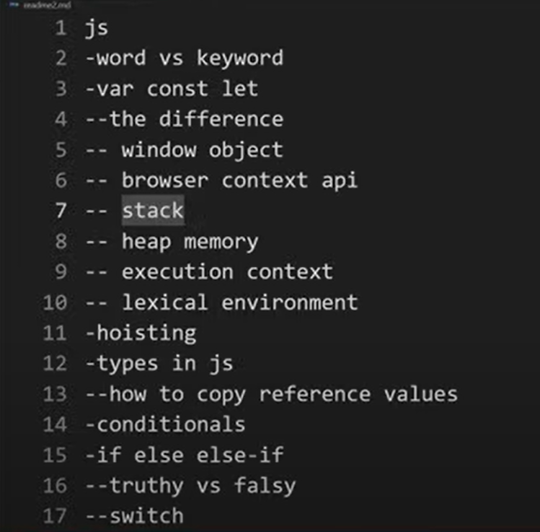

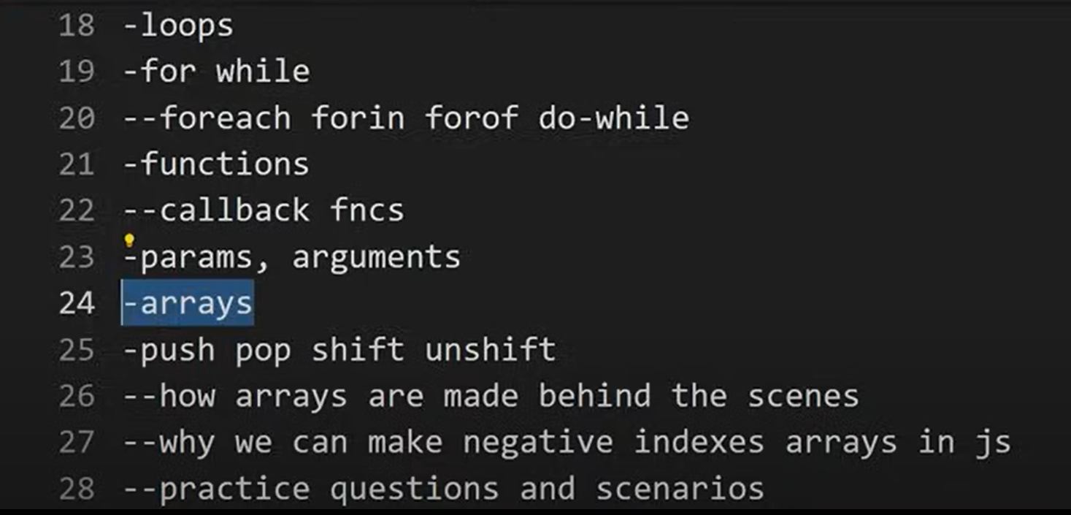

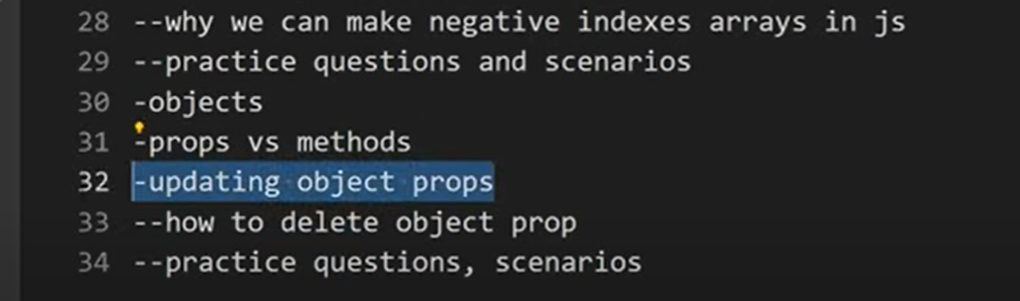

Advance Js without Assynchronus js

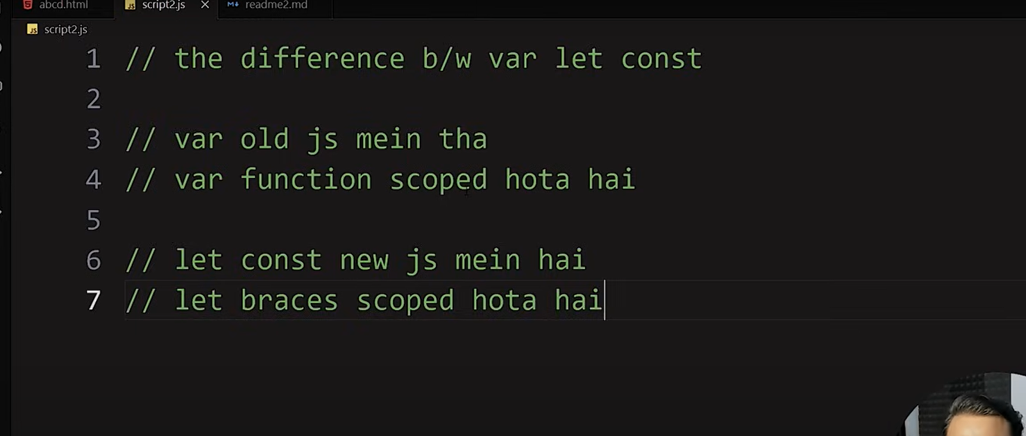

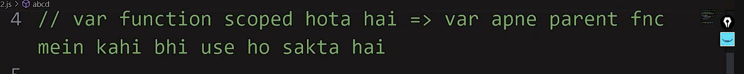

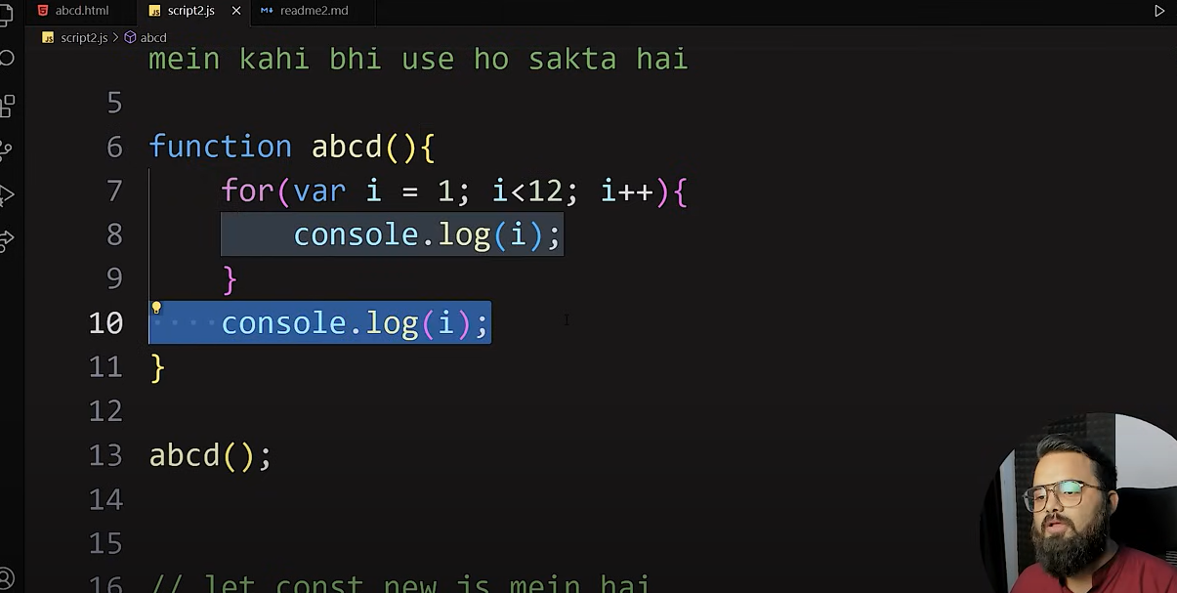  
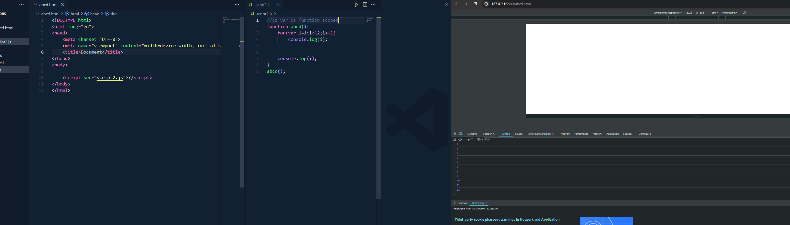

1 theke 12 dekhacche karon shesh er tao dekhacche karon parent function er bhitor i silo loop er poreo

Let const use korle braces porjonto I er value nibe baki tate error show koreche

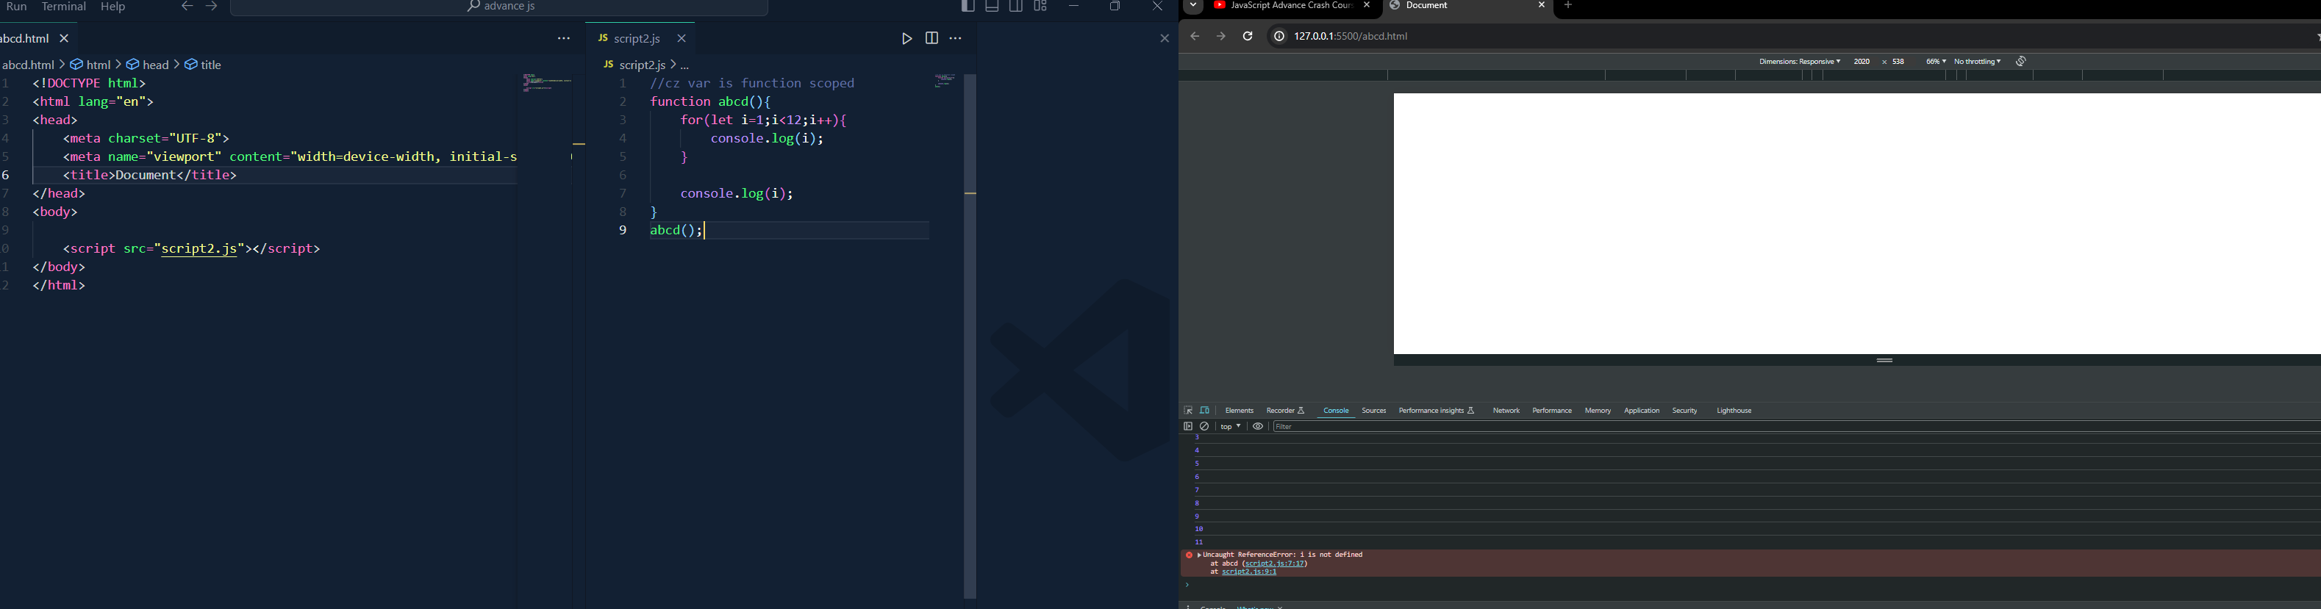

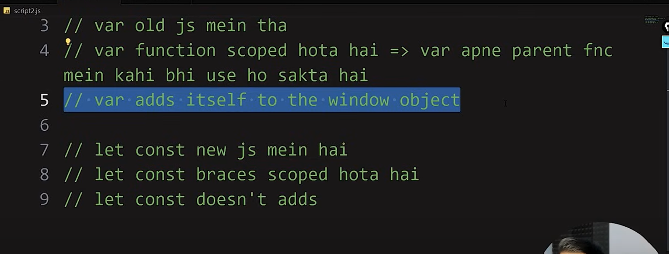

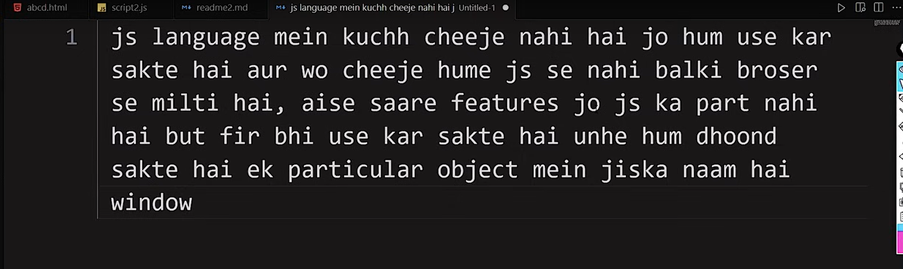

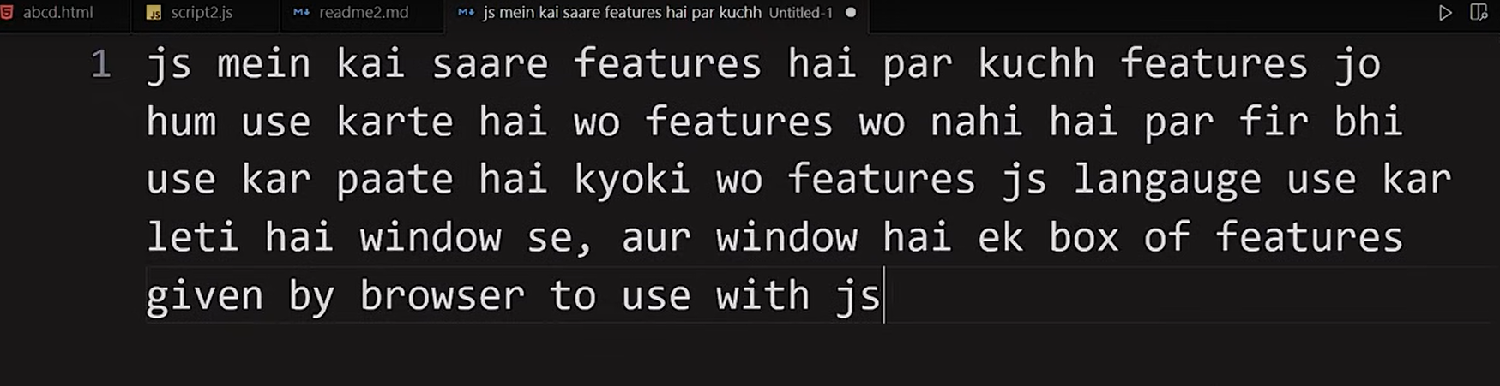

Console e window lekhe search korle shob window objwct feature pabo

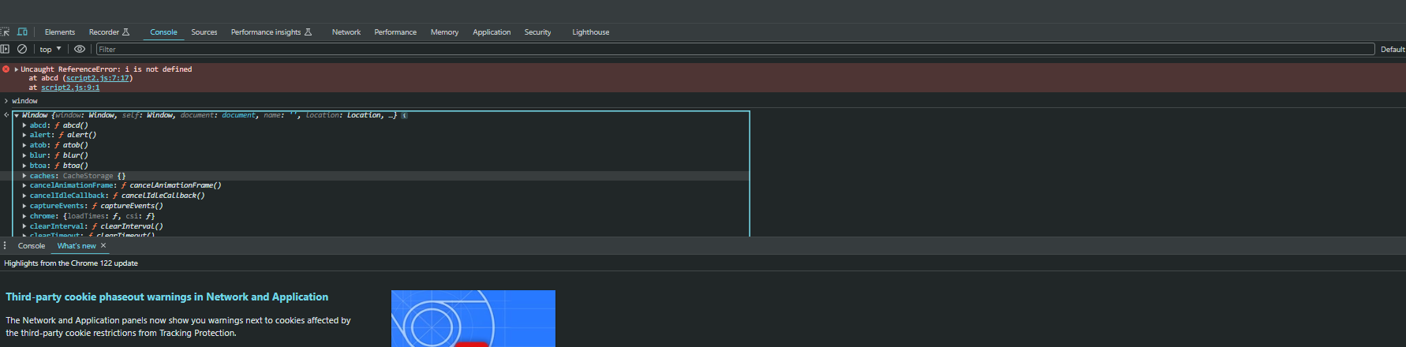

Example: a=12 is exposed in window objet which is not good

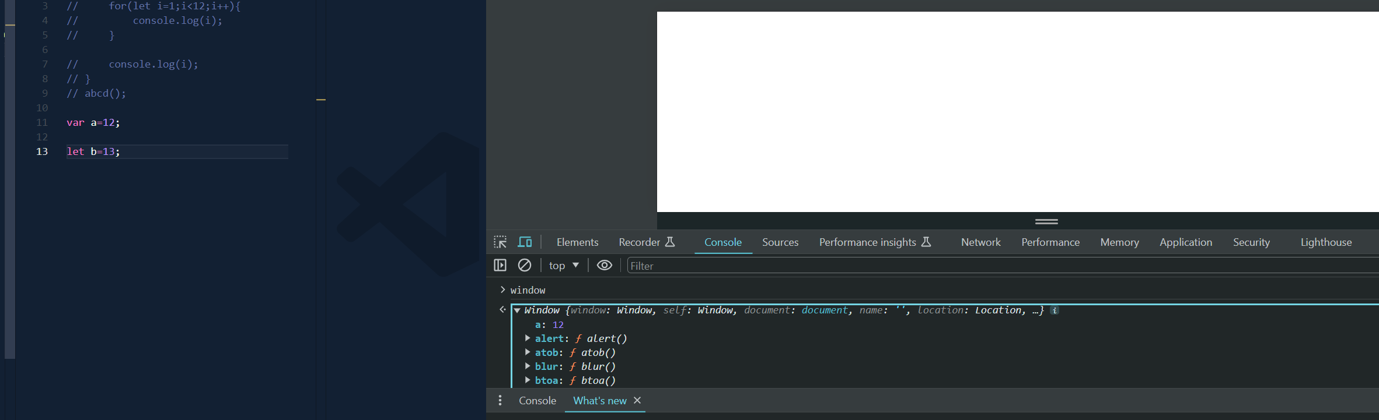

Browser context API

1.window(window object feature)

2.stack

3.Heap memory

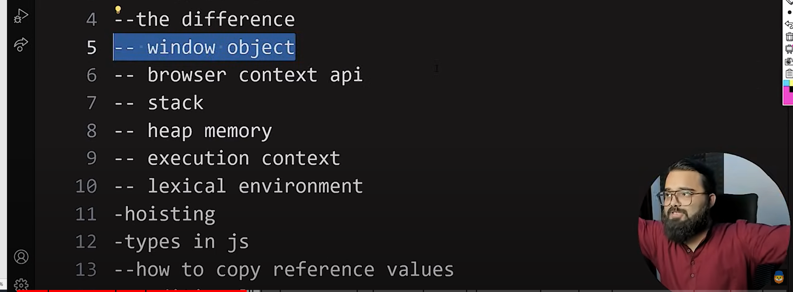

. 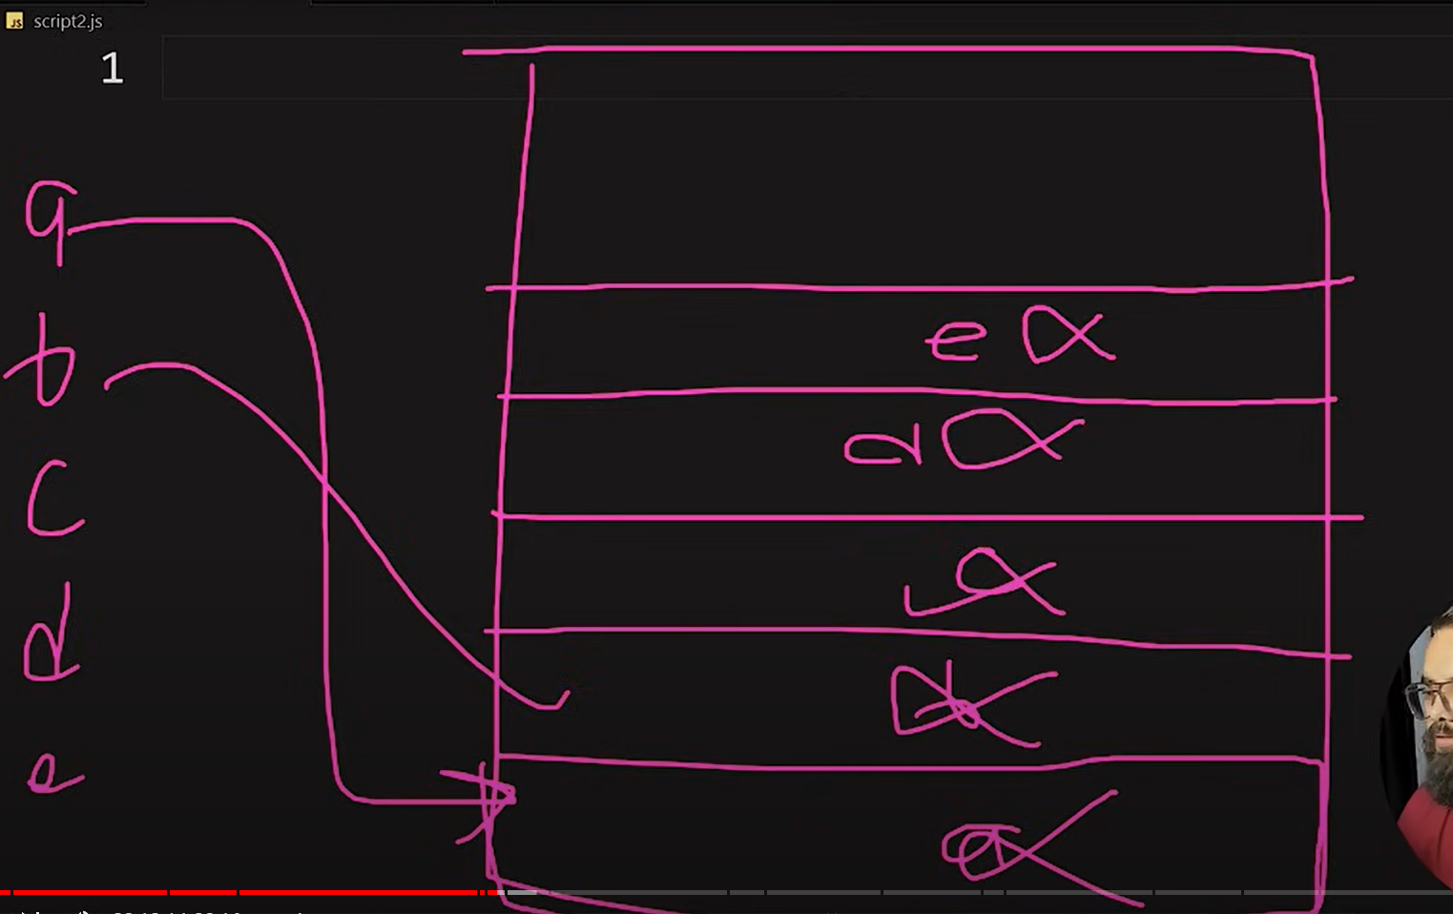

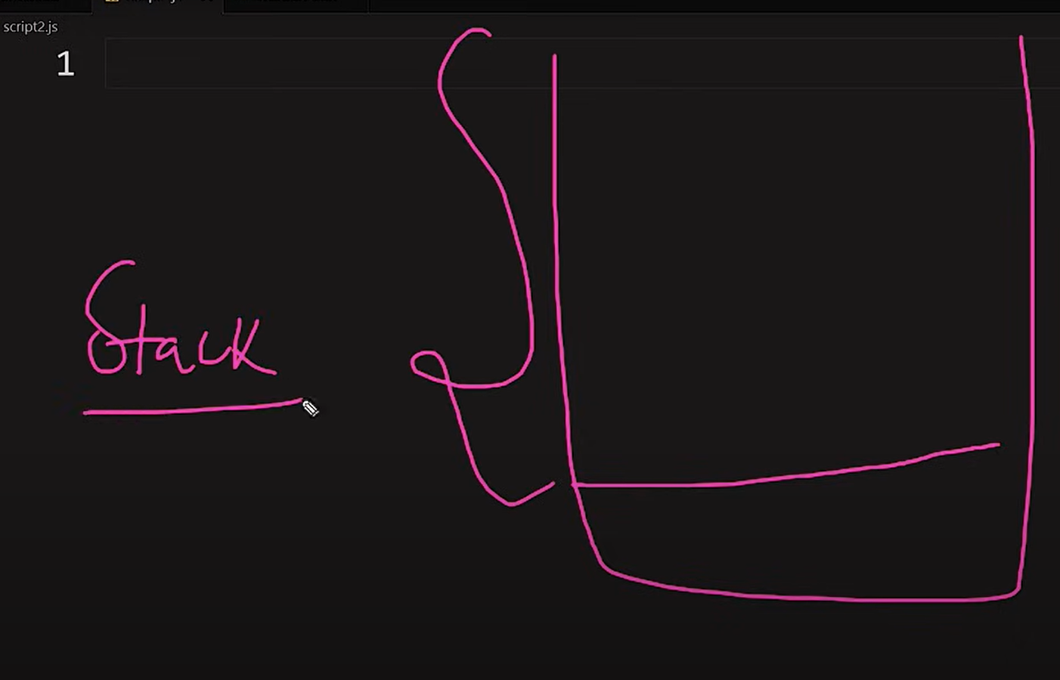

1+2+3+4+5+6 ebhabe aste aste jog korte jay and heap memory the save kore porer number add kore 1+2=3+3=6+4=10 ebhabe

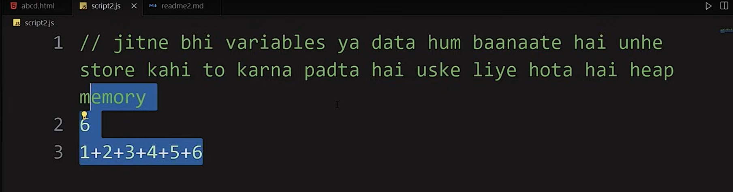

--Executuion context

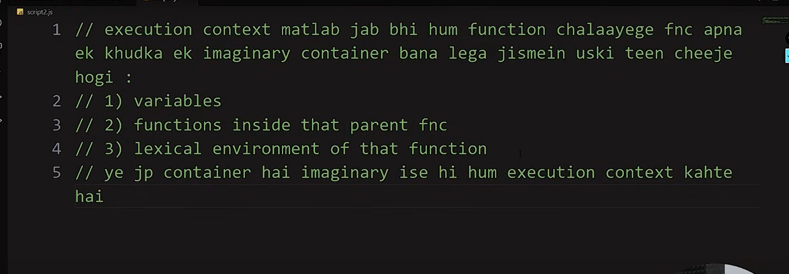

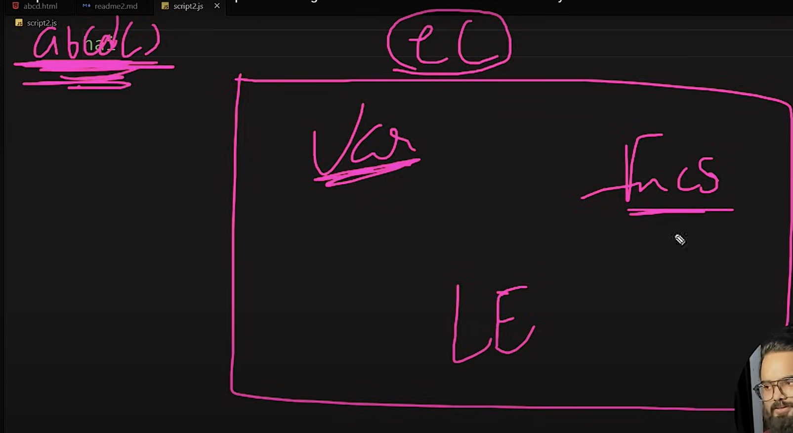

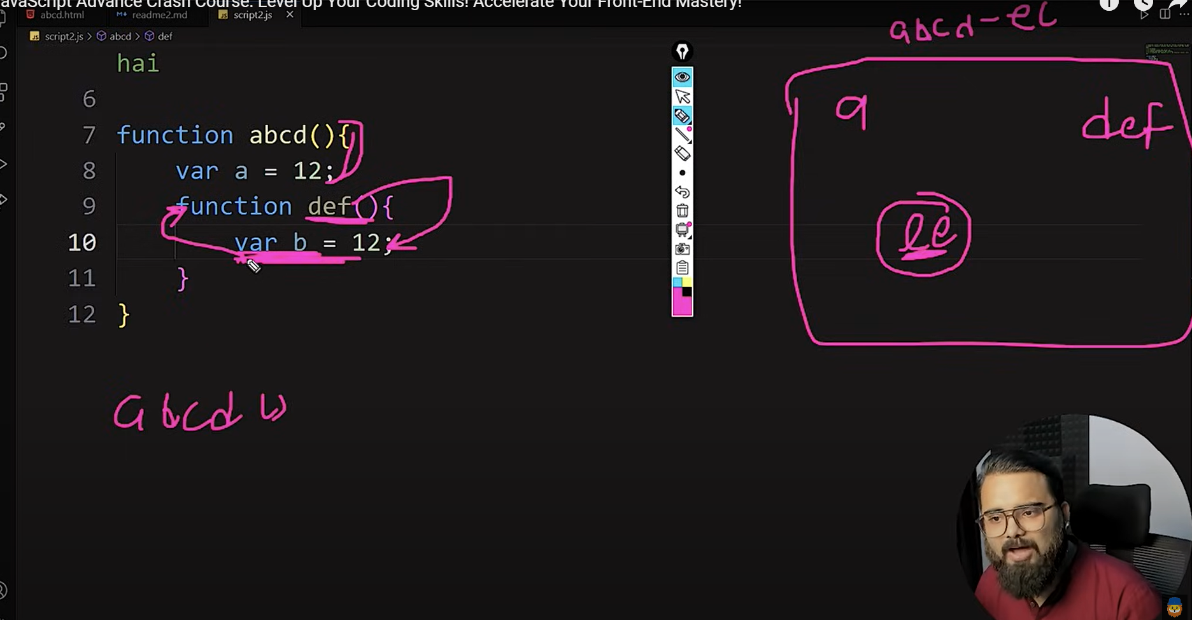

Ekhane abcd function er a variable inside e function def r b access korte parbe na abcd execution container karon var access hoy nearest parent dara r etai holo lexical environment(ki ki access korte parbe bole ) ami parent er jinish access korte pari cildren er na

covered

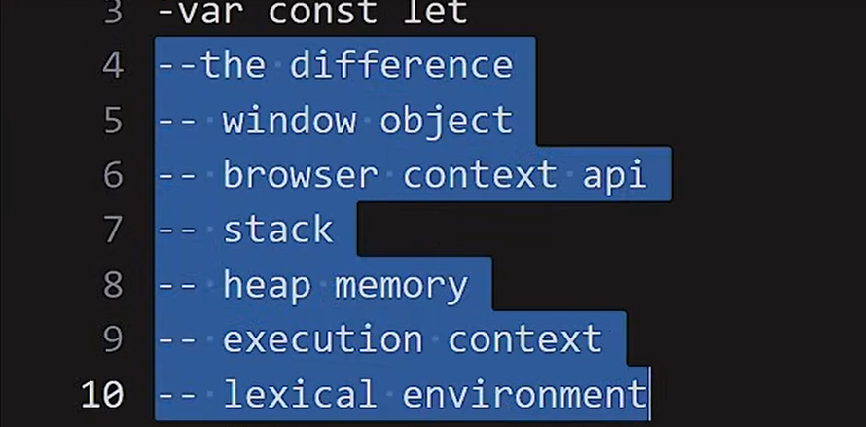

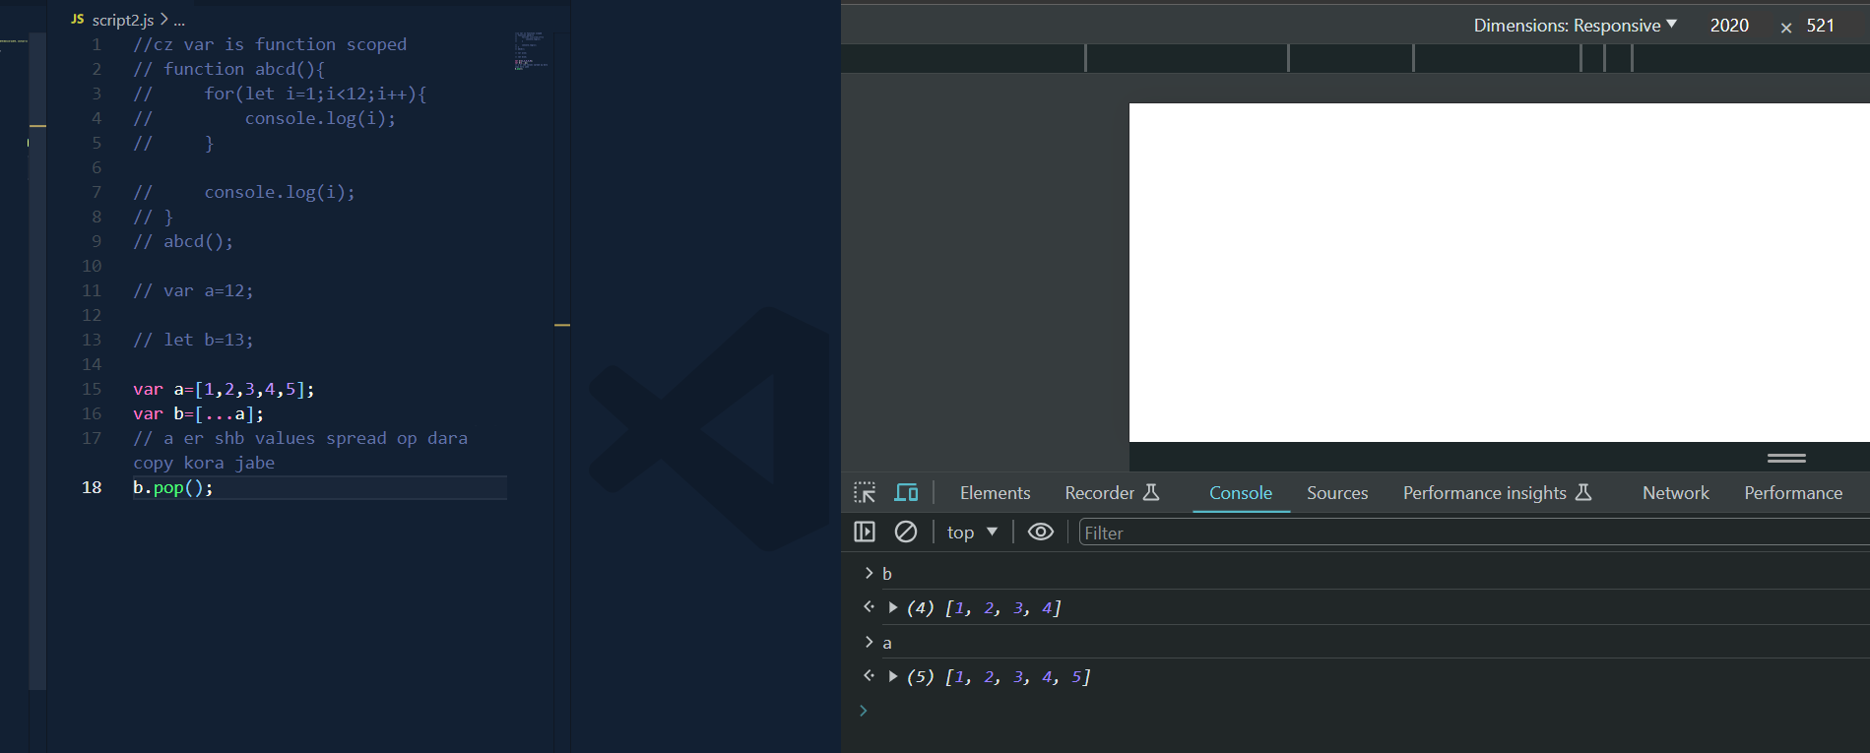reference copy korte spread operator

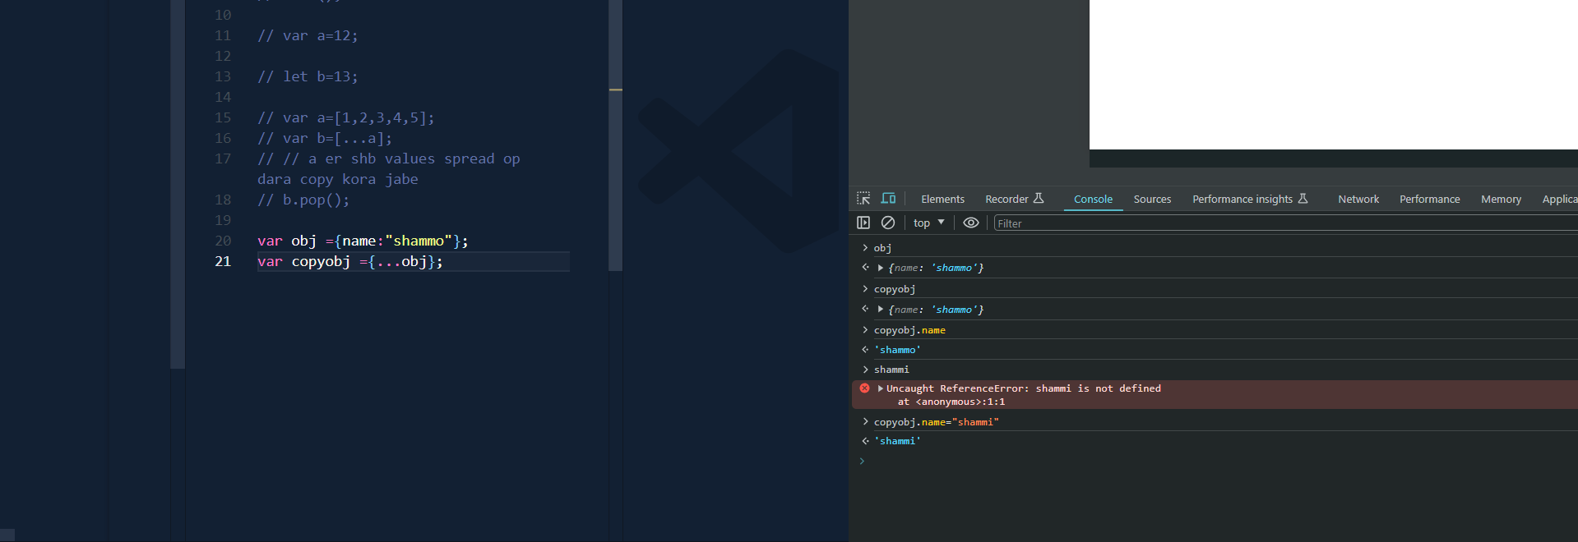

Truthy and falsy

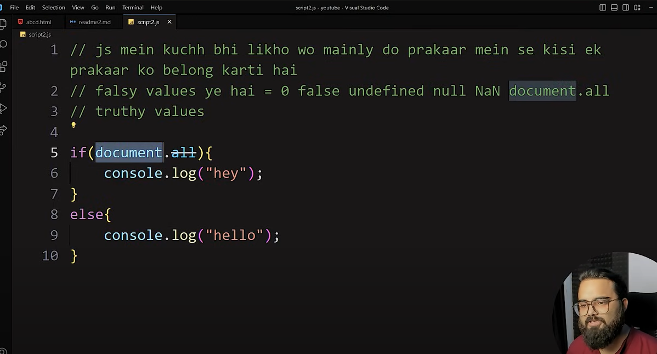



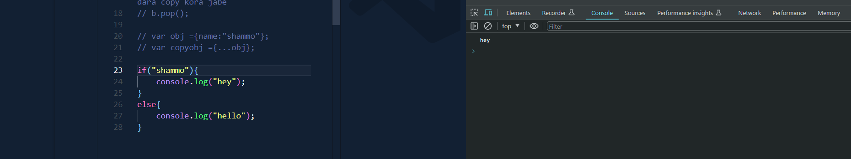

0,Nan,null,document.all bade shb e truthy

--Switch case(just format because it is not used generally)

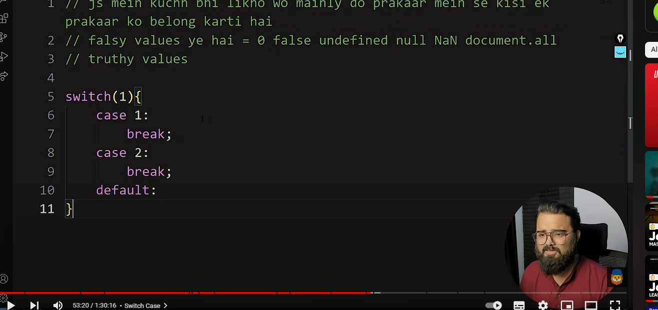

--forEach,forIn,dowhile

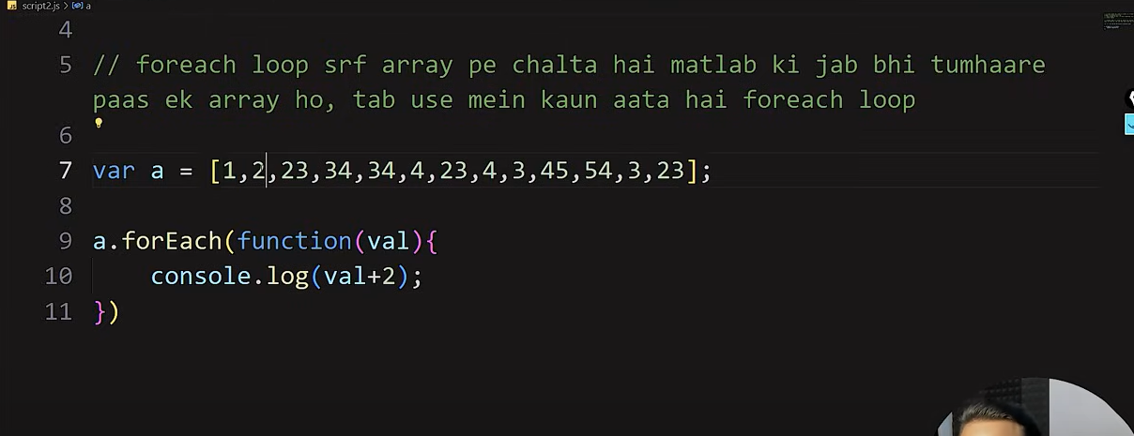

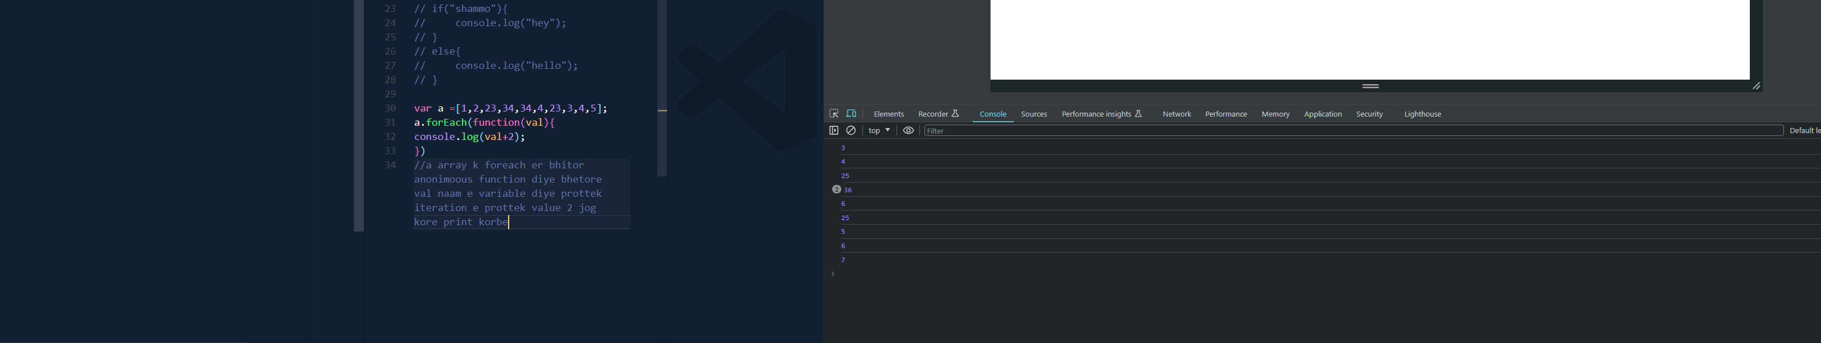

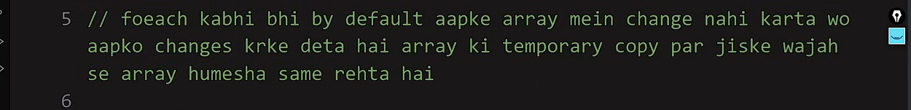

a array er original value er kono change ashe nai

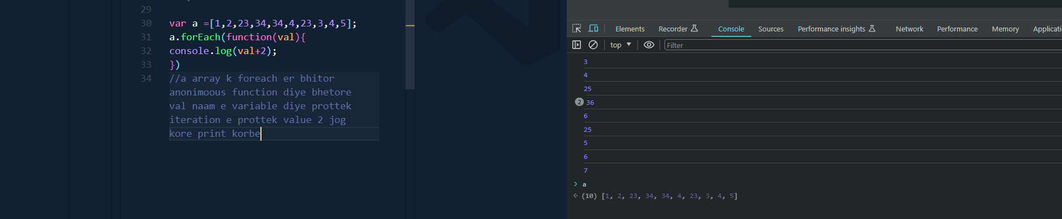

Forin

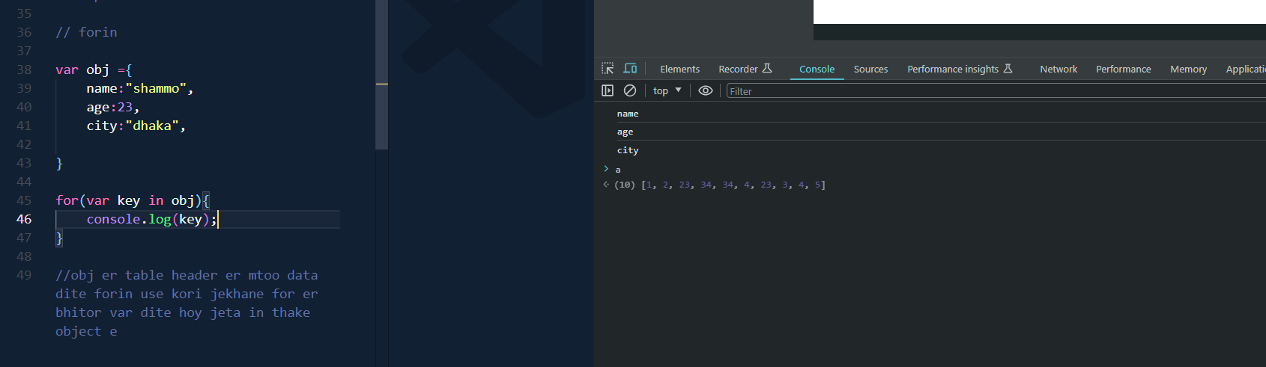

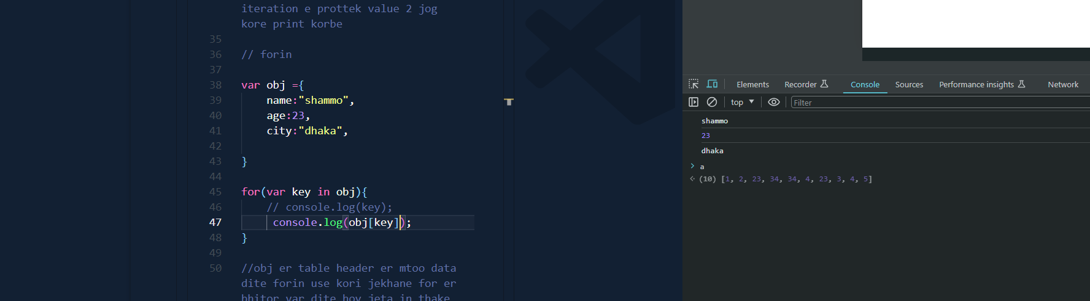

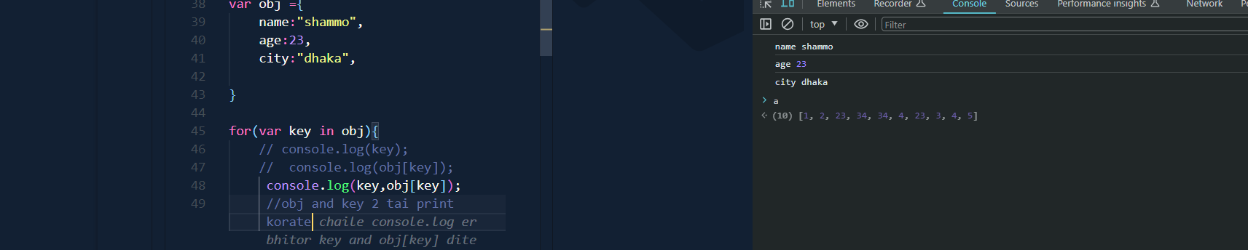

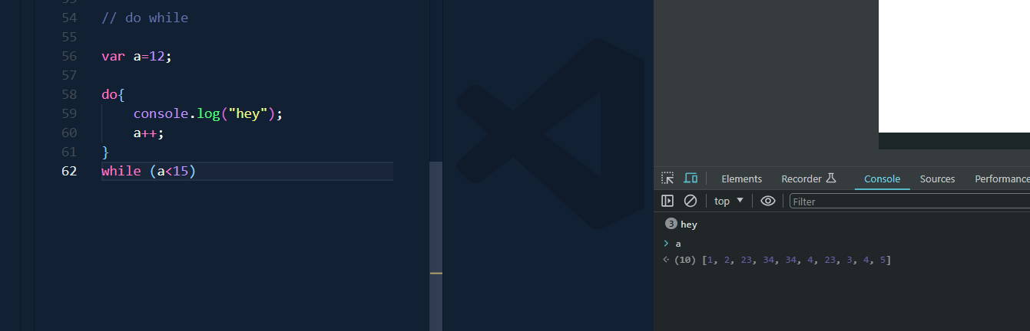

dO WHILE E AGE DO ER KAAJ KORE then while check dey coniditon amra atleast ekbar run korate code do er bhitor diye thn condisiton dite do while use hoy

do-while=atleast 1 time run the code

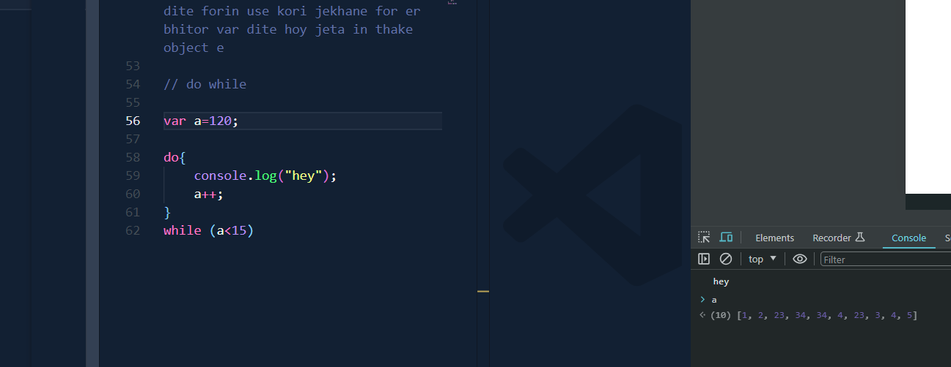

Condition na milar poreo 1 bar hey print korse

**Callback function(pore complee howa code er completion hole js k janano)**

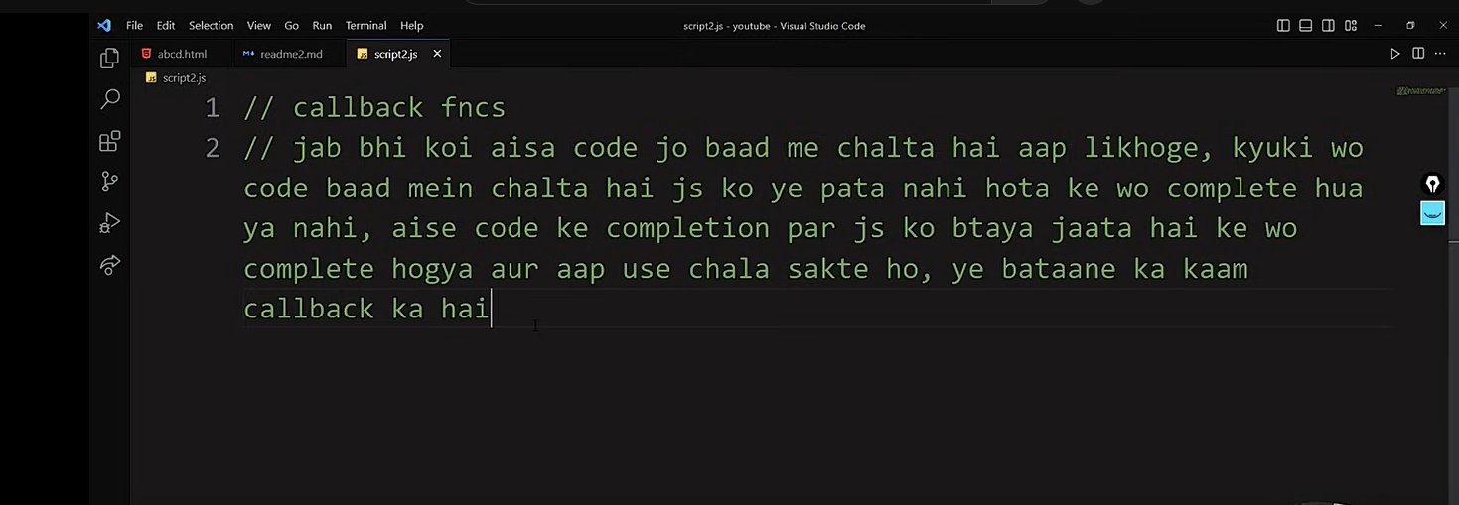

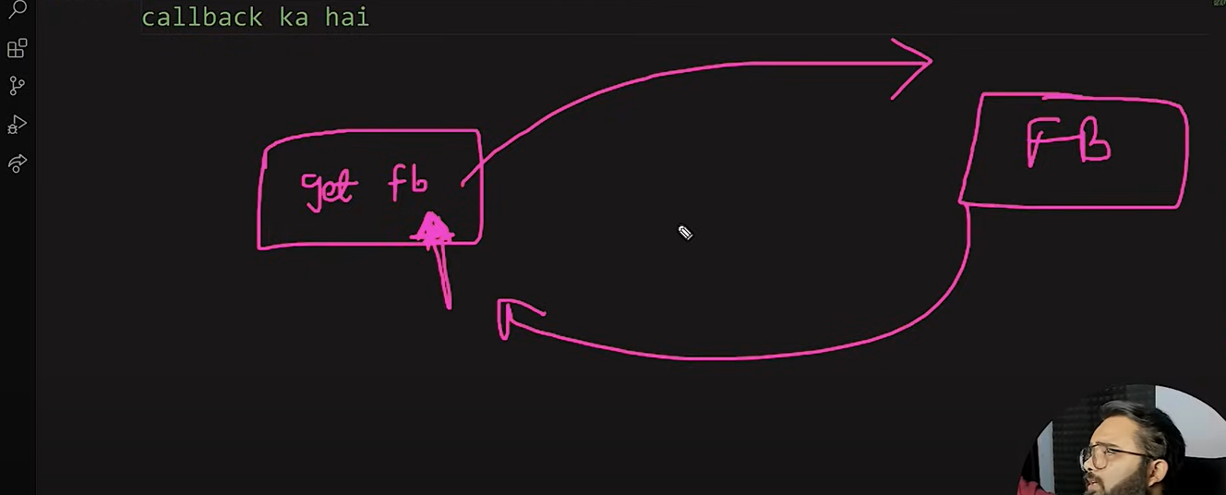

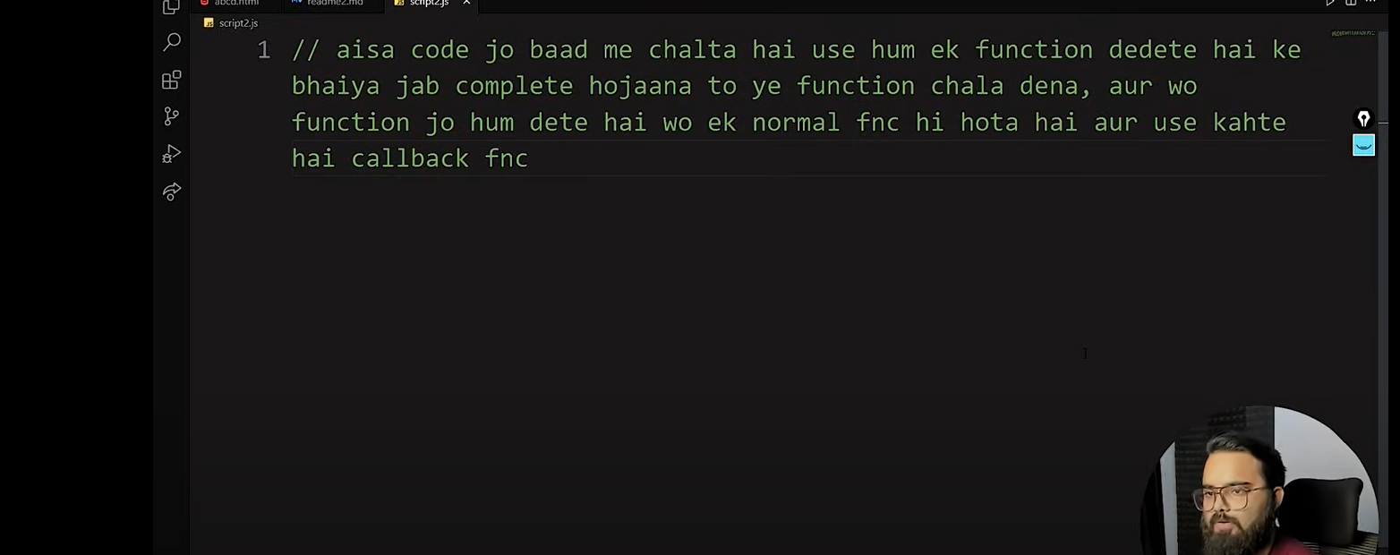

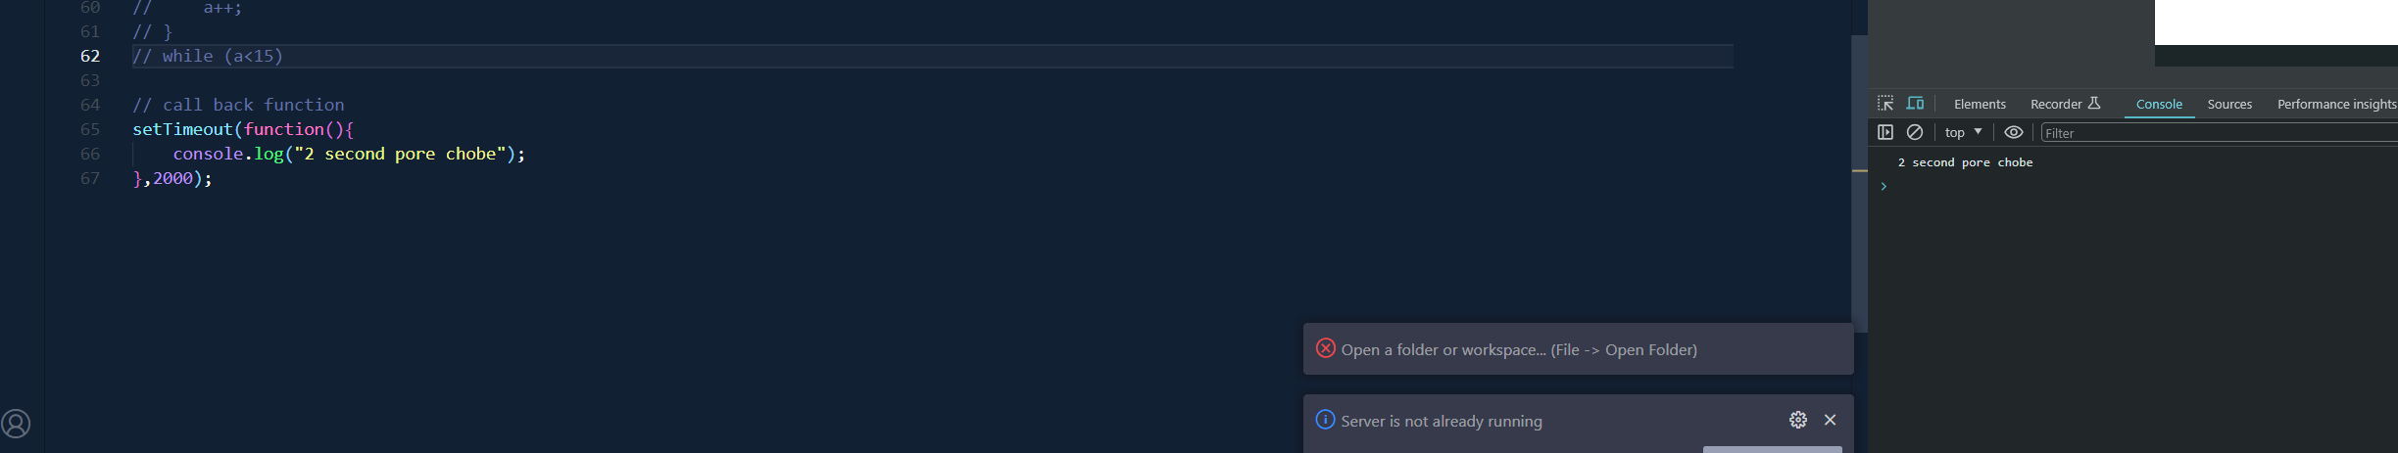

Call back muloto ekta normal function .2000 ekhane millisecond

* First class fncs

Js eshb function first class function jeta value hishebe assign kora jay var e

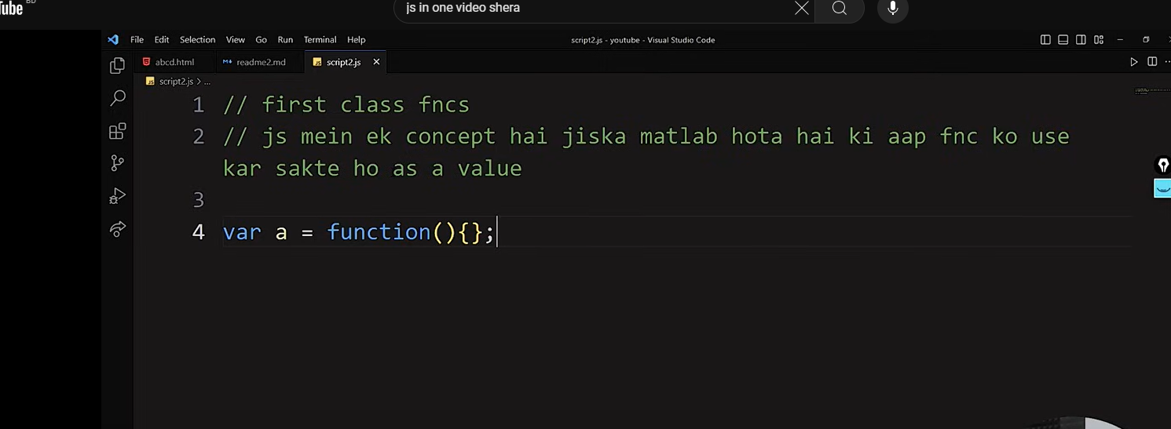

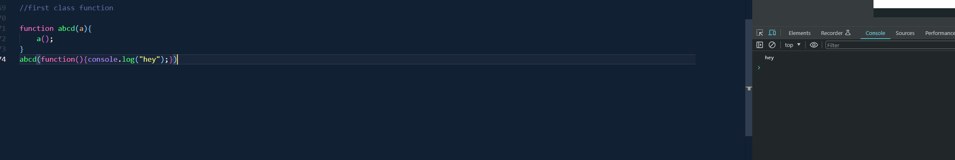

Function abcd er parameter e var a er bhitora run korlam function hishebe karon pore parameter a teh function rakhsi value hishebe

--how arrays are made behind the scenes

Arrays js e object hishebe run hoy

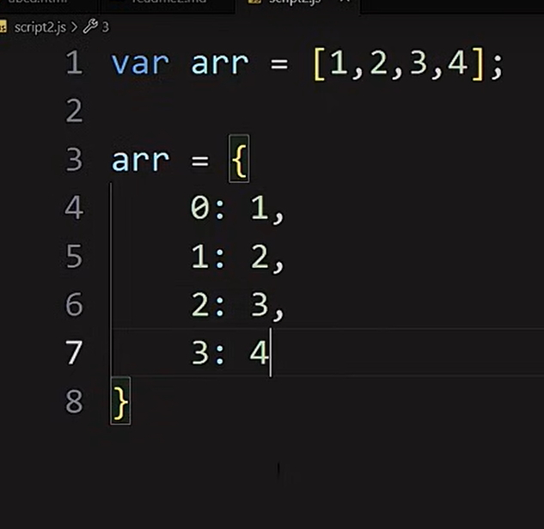

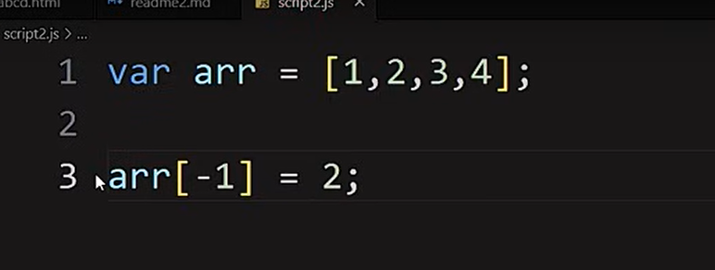

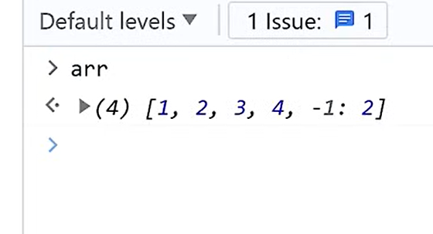

Arr[-1] array te exist korena but obj bole run korse etai example j js e array obj

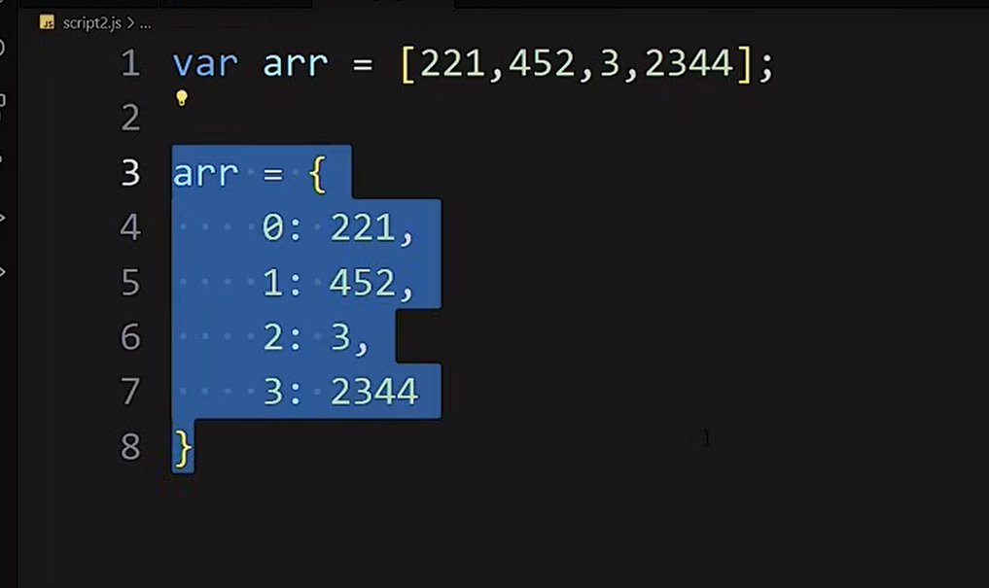



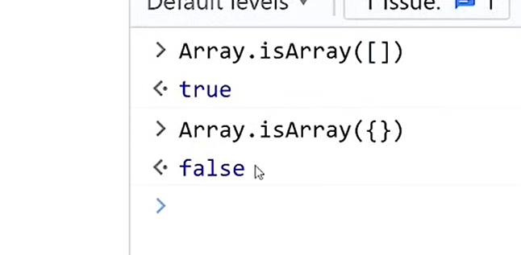

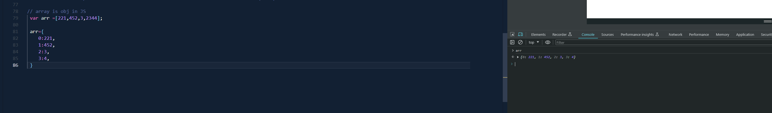

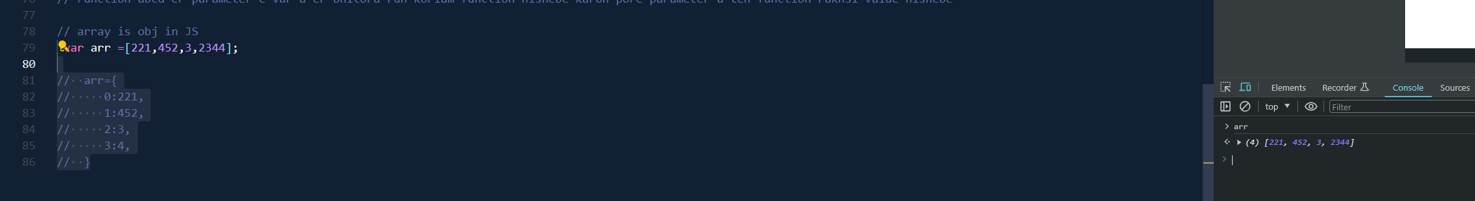

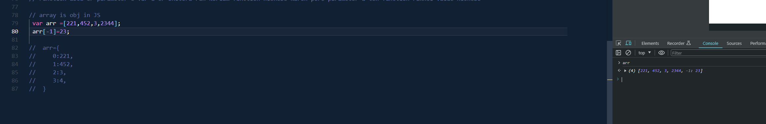

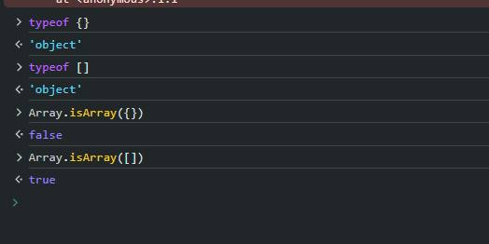

* Updating obj props

